**M3 - Analyse actual test results against expected results to identify discrepancies**

**Introduction**

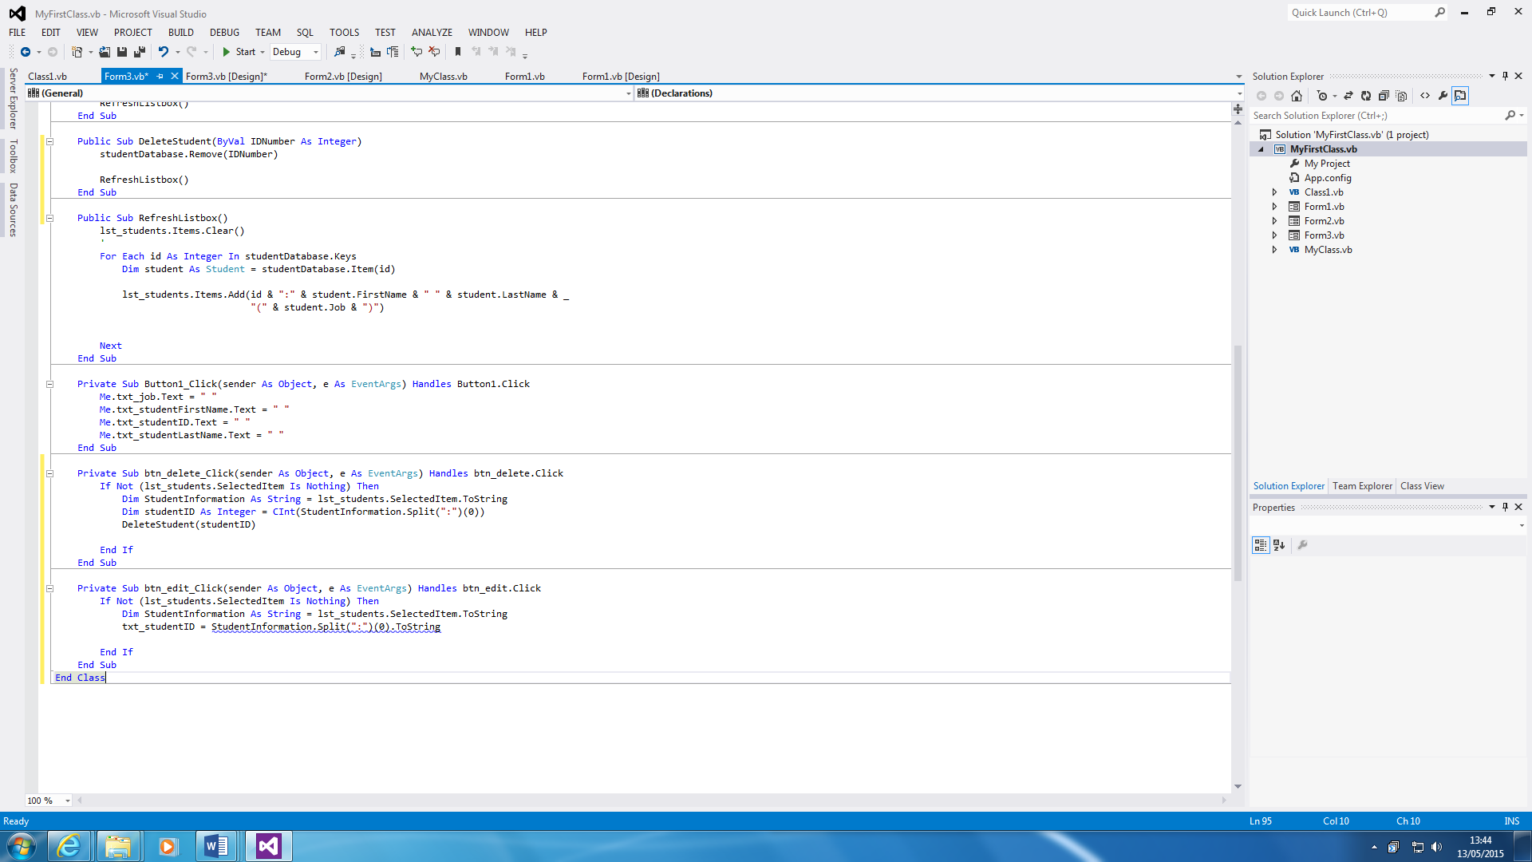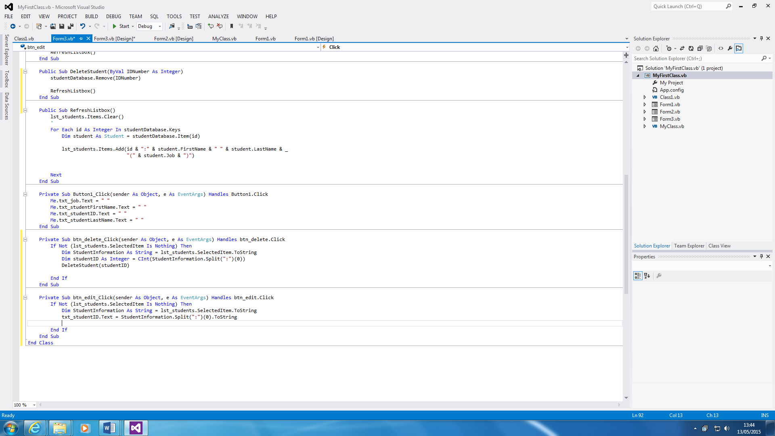In this report, I will explain the errors that I have encountered with the program that I have made.

**1.**

This is an error that I encountered whilst I was typing the program. I could not figure out what was wrong with it, because it would not let me proceed. However, the error was what was written before, “txt_studentID”. I had to add, “Text” for it to link with the Textbox. It is a small error, but I could not figure out what was wrong with it for a little while.

However, the screenshots below shows a different scenario. This shows a small error that I encountered, but it changes the whole content of the program. The Form was Form3 at the beginning of it. I had put Form1 and the customer database was not loading as I expected. It changed, and the database loaded.

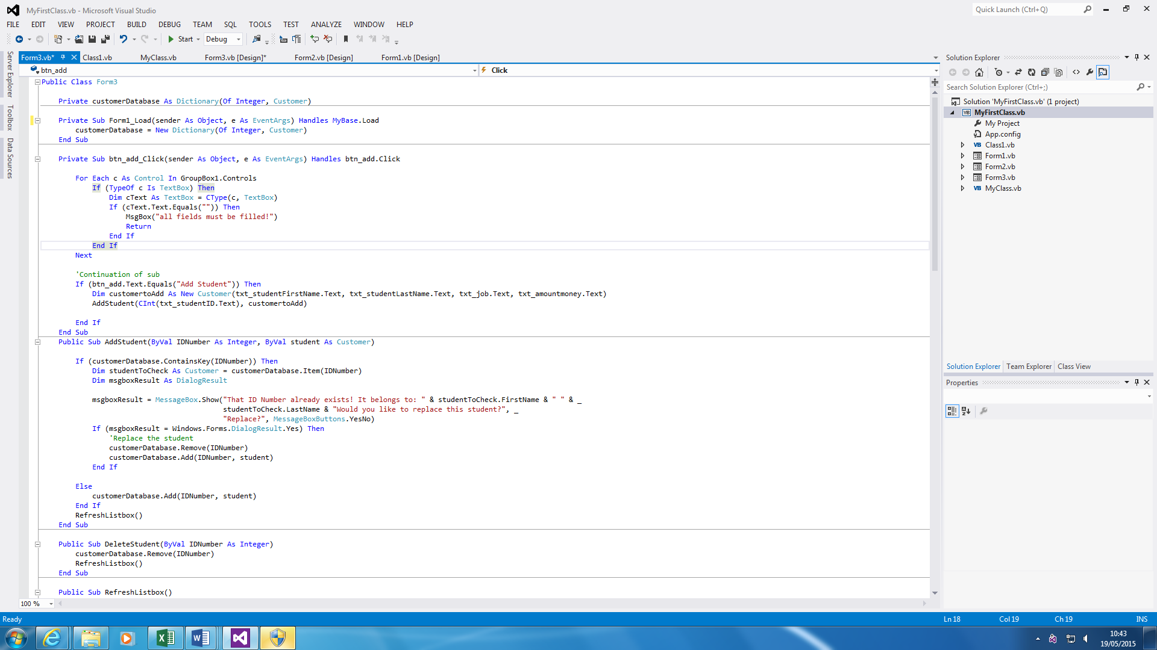

**2.**

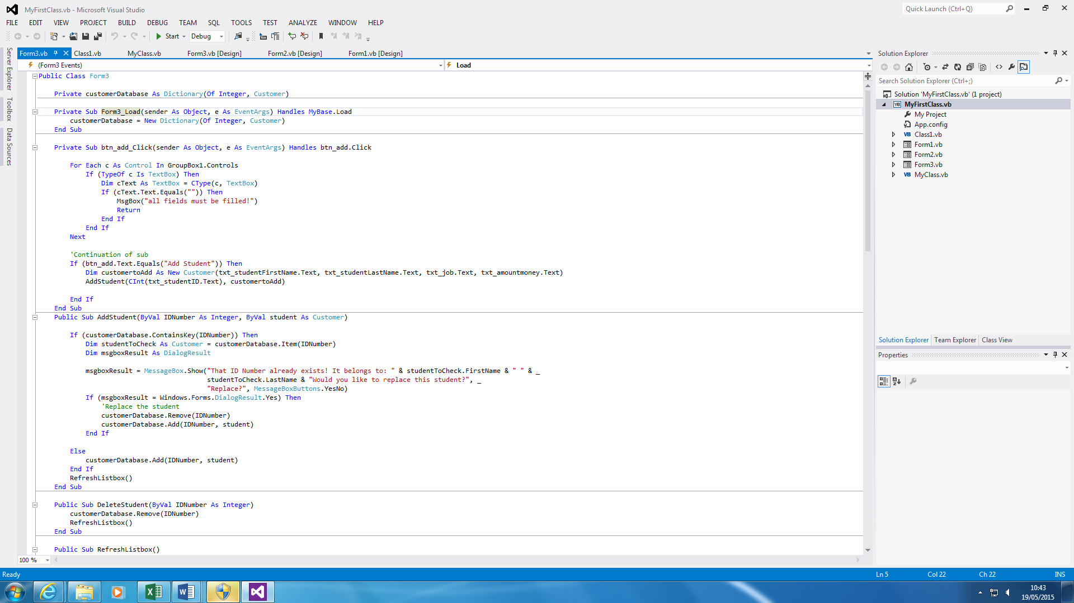

These are the two minor and major big errors that I have encountered. The major one is the second numbered and the minor is the first one.

**Ending the code**

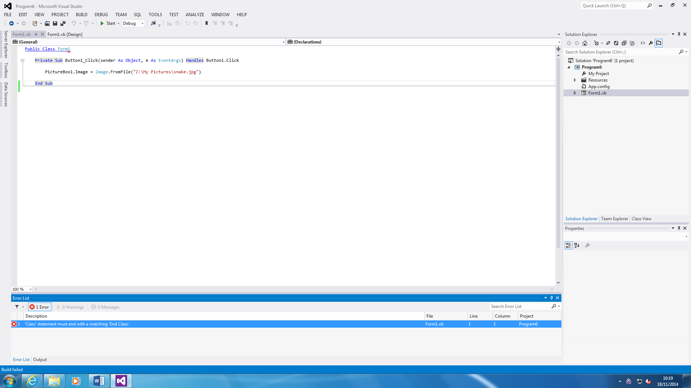



First, the error that says is the statement must end in ‘End Class’. If this is not inserted, the program cannot be started. If any errors that confuses you, i.e. you do not understand what to do, you double click on it and it automatically directs to what the error is. For this, all I did is add ‘End Class’ and there was no more errors within the system. By ‘Ending Class’ to this program, it will end the code. This error is very basic. However, as an example, it works fine.

**Validation**

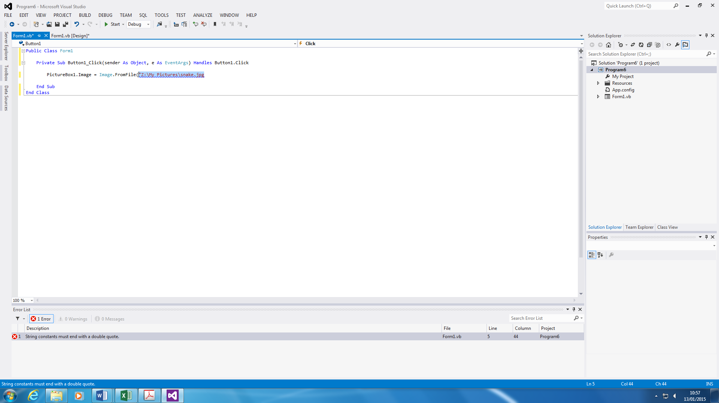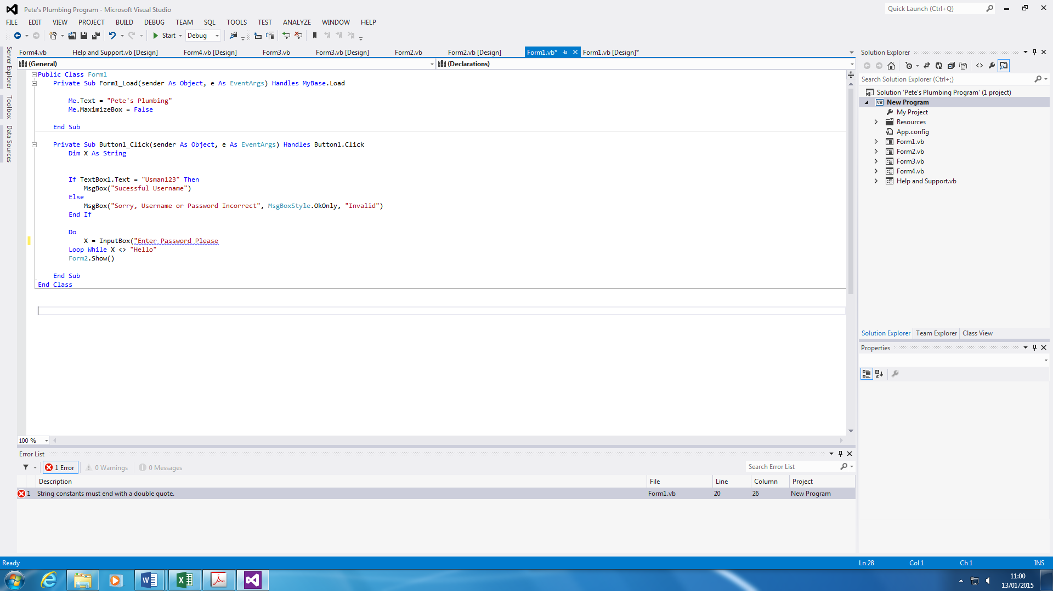

My second error in the program was to validate the program. The screenshot shows that I need to end the message with a double quote. For example, I have to end it like this, (“Enter Password Please”). If this is not ended, the program will read it as an error and it is not finished. As any other error, if this is not complete, the user cannot start the program without completing this error. The error was made, and I had to correct it by typing the rest of the quotes in, and with a closed bracket.

**Print**

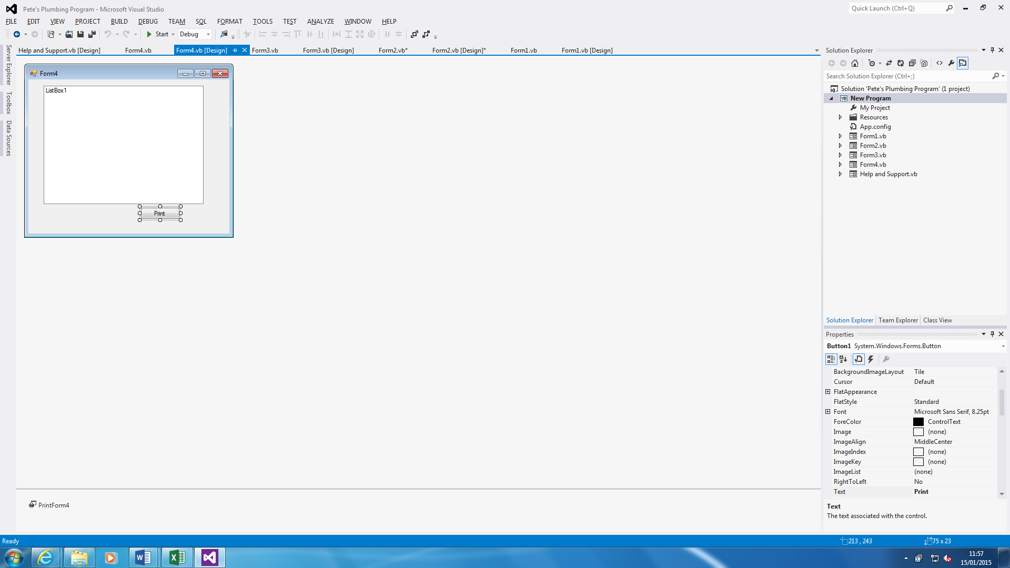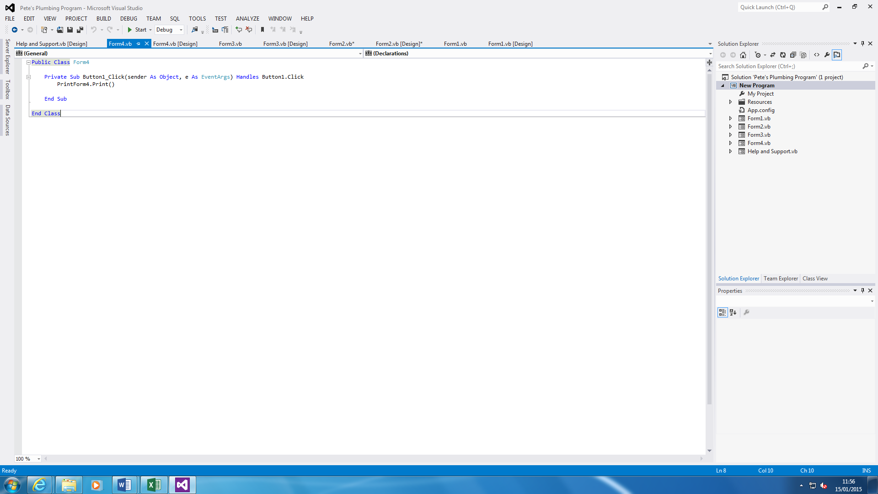

The problem that I faced during the testing was that it could not recognise the code once I typed it in. It did not work because I had not put in the command for it to be actually do the printing. I had to change it from Form1 to Form 4 within its properties. Once this was put in, it worked. This printing is for the Database Form.